**CCCF Scenarios and Strategic Action**

Chaffee County: An Unstable Environment for the Next 18 Months

June 2020

Chaffee County Community Foundation (CCCF) Board

Edward Cooper, Chair

Rick Hum, Vice Chair

Dustin Nichols, Second Vice Chair

Merrell Bergin, Treasurer

Wendy Hall, Secretary

Paul Alexander * Jordan Brown * Megan Leesley * Kayce Penrod

Gordon Schieman * Sydney Schnurr * Rachele Vierthaler

Joseph Teipel, Executive Director

*Publishing Version for Website*

Table of Contents

Purpose & Structure 3

Definitions 3

WeAreChaffee 3

Scenarios 4

The Months of June – August: Slow Full Re-opening of Businesses Including Tourism 4

The Months of Sept. – Dec. 2020 Most businesses open including Tourism 6

The Year of 2021 - Surviving Businesses Open Including Tourism 9

Scenario Implications on CCCF Strategic Priorities 14

Community Vitality 14

Community Health 17

Community Capacity 20

Socioeconomic Background to the Pandemic 23

A few additional data points: 23

The History of Coronavirus and COVID-19 in Chaffee County (a snapshot in time) 24

Sources and Charts 26

Chart 1 – COVID-19 Rates by Nation 26

Chart 2 – COVID-19 Rates by State 27

# Purpose & Structure

Scenario planning aims to define critical uncertainties and develop plausible outlooks for thefuture in order to discuss the potential outcomes/impacts and provide potential responses for each one of them.

The Chaffee County Community Foundation (CCCF) Board is charged with the task of anticipating what Chaffee County may need from the CCCF before the actual need arises. As health and economic issues drive the local and broader society to respond to changing conditions, the CCCF will realign our strategic initiatives and actions with the changing environment.

Below, we will present the outcomes (direct product), impacts (secondary and tertiary products) and actions through 2021 for the Chaffee County Community Foundation based on the Board’s approved strategic initiatives. For the Foundation’s operational purposes, we will add additional elements of timelines, responsibility for action and fiscal or other resources needed to each of the items in the table below.

This document begins with optimistic and pessimistic scenarios for each of three phases:

* June thru August, 2020
* Sept – Dec, 2020
* 2021

The scenarios are followed by an overview of the most likely implications for each of CCCF’s strategic initiatives along with corresponding strategies that CCCF will take.

Finally, COVID background, reference charts, and additional backup documentation.

# Definitions

Resilient local economies defined by the CCCF:

* Resilient – able to withstand or recover quickly from difficult situations.
* Local – In Chaffee County, primarily for Chaffee County.
* Economy – while sometimes narrowly confined to Gross Domestic Product (GDP), or financial terms, ‘economy’ is the system in which we live. We comprise and are affected by the economy with every decision we make.

# WeAreChaffee

CCCF believes that together we can advance all aspects of Chaffee County. The Chaffee Community is one---just as a car of body or building are considered one---with many unique parts. We seek to build shared visions and align our community’s development with an underlying common purpose and core set of values. CCCF seeks to bring disparate parts of Chaffee County together to find our common understanding and honest differences. We will approach change with the strategies and objectives above (what, why) and use WeAreChaffee as the vehicle to transport the community to the who, what and when. By using other communities’ best practices, storytelling and guided dialog as central components, we will build on the spark to engaged community conversations and build a more resilient community of mutual understanding and respect.

# Scenarios

What are the possible scenarios regarding the COVID-19 outbreak that might playout with the implementation of the Chaffee County Re-Opening Plan? Below, we will provide an optimistic and a pessimistic set of scenarios based on our assumptions and informed by the data and research available in May 2020. The actual outcome will likely fall somewhere in the middle of these descriptions. Yet as a community and as CCCF, it is wise to prepare for the extremes.

## The Months of June – August: Slow Full Re-opening of Businesses Including Tourism

Outside Influences: During this phase, outside influences may be significant. If tourism is allowed, and probably encouraged, then the spread of COVID-19 in the Front Range and other areas of the country that send tourists to us, may cause the County to isolate again to avoid importing the virus, even if the County is doing a good job with all its efforts.

|  |  |  |  |
| --- | --- | --- | --- |
| Category | Optimistic Scenario |  | Pessimistic Scenario |
| Social Distancing | * Most vulnerable residents respect stay at home unless necessary. * Those that go out, wear facemasks and keep reasonable distance. * 50% of visitors respect the request to wear facemasks and keep a reasonable distance. * No gatherings of more than 50 and all major events are cancelled. |  | * Most do not follow the stay at home recommendations. * Some wear facemasks and keep reasonable distances, but many do not. * Background of regional protest movements and spread of misinformation and divisiveness bubble to the surface here. * Churches and other small groups start to gather again. |
| Testing and Contact Tracing | * Testing capacity continues to increase significantly. * Anyone in contact with someone who is possible positive case can be tested. * Rapid tests are becoming more available at the hospital for all who employees. * Repeated testing available   to all associated with Columbine Manor.   * CCPH has the capacity to do thorough contact tracing for all possible and positive cases. * Rafting and lodging companies, churches and groups fully cooperate with contract tracing. |  | * Testing capacity continues to be limited. * Only symptomatic patients are tested. * Medical staff receive testing but results continue to take 72 hours. * Under pressure, HRRMC agrees to test all clinical workers but not back of the house staff. * CCPH has only limited capacity to do contact tracing. * Rafting and lodging companies are, for the most part, not willing or capable to cooperate in contract tracing. |
| Treatments | * Best treatment practices continue to improve with world-wide experiences. * Some treatments begin trials |  | * Treatment practices continue to be rudimentary. * No promising treatment trials, at this time. * Treatment costs continue to spiral and outcomes do not improve measurably. |
| Number of Reported confirmed Cases of COVID-19  Reported confirmed Cases of COVID-19 (continued) | * The number of cases confirmed in the County increases as more testing is done. * Visitors to the County import the coronavirus and spread to some working in the tourism industry. * These cases are caught early, so the exponential growth is minimized. * The cases associated with Columbine Manor are contained and do not spread into the community. |  | * The number of positive cases rises and the number of those carrying the virus, but asymptomatic also increases. * The overall number of cases starts to increase significantly. * Not all cases associated with Columbine Manor are contained and there are more resident fatalities. * Columbine Manor is forced to evacuate the sickest residents, shut down for complete overhaul, displacing residents to other over-burdened facilities before moving back, causing extreme hardship. |
| Operations at the Hospital | * The number of cases in the community are within the HRRMC capacity. * Non-COVID-19 procedures can continue, but many be limited as those seeking treatment for COVID-19 increases. |  | * The number of cases requiring medical intervention raises to 20% of cases. * Hospitalization continues to rise to about 5% of cases and those requiring ICU confinement to about 1-2% of cases. * HRRMC has to suspend any non-emergency procedures. * Revenues and profit margins continue to fall and specialists leave. |
| Economy | * More jobs are available and relieves some of the unemployment. * The number of visitors remains significantly below 2019 numbers. * More businesses may close by year end. * Unemployment rate continues in the 7 – 10% range. * Some out-migration has and continues to occur. * County and municipal Sales Tax Revenue 25 – 35% below 2019 levels. In most cases these can be covered by reserves and reduced capital expenditures. * Residential Real Estate prices remain at current level but less market activity. * Commercial Real Estate values drop some, but not significant. * Rents frozen at current levels; tenants struggle but most remain. |  | * A limited number of jobs are available and relieves some of the unemployment. * If overall COVID-19 numbers regionally increase, there are likely to be restrictions on travel and tourism. * Many businesses that rely on tourism are likely to close or downsize by end of summer. * Unemployment rate continues in the 20– 30% range (this is for those seeking work not the total potential workforce). * County and municipal Sales Tax Revenue up to 50% below 2019 levels. In most cases these cannot be covered by reserves and reduced capital expenditures. Some reduction of service levels and furloughs of non-critical positions will have to occur. * Residential Real Estate prices remain at current level but less market activity. * Commercial Real Estate values drop significantly as more businesses close. * In order to fill newly empty spaces, landlords must offer incentives and reduce upkeep/services. |
| Impact on Future Phases | * With success in the activities thus far, the opening of the community to fall and winter tourism can proceed, unless external forces significantly impact tourism. |  | * The capacity of HRRMC and CCPH becomes overwhelmed. The decision to proceed with Phase 3 may well be delayed or suspended. * Further travel restrictions and limitation on tourism may be reinstated. |

## The Months of Sept. – Dec. 2020 Most businesses open including Tourism

Outside Influences: During this phase, outside influences may be significant. If tourism is allowed, and probably encouraged, then the spread of COVID-19 in the Front Range and other areas of the country that send tourists to us, may cause the County to isolate again to avoid importing the virus, even if the County is doing a good job with all its efforts.

One of the more significant outside influences is the development of treatments and even the possibility of a vaccine. The impact on local government spending will depend in large part on how much funding comes to the community from Federal and State sources. Currently, the Federal government is holding further response and the State of Colorado is projecting a $3 billion dollar deficit in the next fiscal year budget, which, by law must be balanced. Impacts of Tabor/Gallagher affect budget severely.

|  |  |  |  |
| --- | --- | --- | --- |
| Category | Optimistic Scenario |  | Pessimistic Scenario |
| Social Distancing | * Most vulnerable residents respect stay at home unless necessary. Isolation increases mental health challenges. * Of those that go out, most wear facemasks and keep reasonable distance. Locals weary of “mask fatigue.” * Some visitors respect the request to wear facemasks and keep a reasonable distance. * No gatherings of more than 50 and all major events are cancelled. |  | * Few follow the stay at home recommendations. * Some wear facemasks and keep reasonable distances, but many do not. * Social unrest increases as do verbal and physical confrontations. Local law enforcement is forced to intervene, against their personal wishes. * Churches, small groups and performing arts are asked to reduce numbers or resume virtual gatherings. |
| Testing and Contact Tracing | * Testing capacity continues to increase significantly. * Anyone in contact with someone who is possible positive case can be tested. * Rapid tests are becoming more available at the hospital for all employees. * Repeated testing available   to all associated with Columbine Manor.   * CCPH has the capacity to do thorough contact tracing for all possible and positive cases. * Lodging companies fully cooperating with contract tracing. |  | * Testing capacity continues to be limited. * Only symptomatic patients are tested. * Medical staff receive testing but results continue to take 72 hours. * HRRMC still has not tested all clinical and back of house staff. * CCPH has only limited capacity to do contact tracing. * Lodging companies are, for the most part, not willing or capable to cooperate in contract tracing. |
| Treatments | * Best treatment practices continue to improve with worldwide experiences. * More effective treatments are becoming available. * A vaccine may start to be available. In early 2021 |  | * Treatment practices continue to be rudimentary. * No effective treatments are available at this time. |
| Number of Reported confirmed Cases of COVID-19 | * The number of cases confirmed in the County increases as more testing is done. * Visitors to the County import the coronavirus and spread to some working in the tourism industry. * These cases are caught early, so the exponential growth is minimized. * The cases associated with Columbine Manor are contained and do not spread into the community. |  | * The number of positive cases rises and the number of those carrying the virus but asymptomatic also increases. * The overall number of cases starts to increase significantly. * Not all cases associated with Columbine Manor are contained. |
| Operations at the Hospital | * The number of cases in the community are barely within the HRRMC capacity. * Non-COVID-19 procedures can continue, but may be limited as those seeking treatment for COVID-19 increases. |  | * The number of cases requiring medical intervention is about 25% of total cases. * The number of cases requiring hospitalization continues to rise to about 5% of the infected population and 1-2% requiring care in an ICU. * HRRMC has to suspend any non-emergent procedures. * If the number of cases overwhelms the capacity of HRRMC, pressure to isolate the County is likely. |
| Economy | * More jobs are available and relieves some of the unemployment. * The number of visitors remains significantly below 2019 numbers. * More businesses may close. * Unemployment rate continues in the 7 – 10% range. * Some out-migration has and continues to occur. * “Shoulder season” visitors (hunters, foliage, heritage tourism and early ski season) return but in smaller numbers * County and municipal Sales Tax Revenue 25 – 35% below 2019 levels. In most cases these can be covered by reserves and reduced capital expenditures but only through 2020. * Residential Real Estate prices remain at current level but less market activity. * Commercial Real Estate values drop some, but not significant. * Some tenants do not renew their leases or seek drastic reductions. |  | * A limited number of jobs are available and relieves some of the unemployment. * If overall COVID-19 numbers regionally increase, there are likely to be restrictions on travel and tourism. * Many businesses that rely on tourism are likely to close before or at year end. * Unemployment rate continues in the 15 – 20% range. * Visitors from across the U.S. and Europe, coupled with colder/indoor weather cause a spike in cases. * County and municipal Sales Tax Revenue 50% below 2019 levels. In most cases these cannot be covered by reserves and reduced capital expenditures; therefore, some reduction in current service levels and furloughs will be necessary. * Budgets for 2021 are adopted in November with cutbacks in operations, capital and staffing * Residential Real Estate prices start to drop with far less market activity. * Commercial Real Estate values drop significantly. Many shuttered storefronts in downtown areas. * Commercial property owners may sell at depressed prices and exit the area. |
| Public Schools | * Public Schools and CMC reopen in the fall; however, mitigation factors are needed to prevent the spread of the virus at schools. * Some school activities (e.g. contact sports) may have to be adapted or greatly curtailed. |  | * The schools may have to institute a hybrid program of distance learning and some personal instruction with small groups. * Schools may have to split times of the school day or days of the week to minimize class sizes and keep students at acceptable distances. * Most school activities, sports travel/field trips may be cancelled, leaving only core coursework. |
| Impact on Future Phases | * With success in the activities thus far, the opening of the community to fall and winter tourism can proceed. |  | * If the capacity of HRRMC and CCPH becomes overwhelmed. The decision to proceed with Phase 3 may well be delayed or suspended. * Further travel restrictions and limitation on tourism may be reinstated. |

## The Year of 2021 - Surviving Businesses Open Including Tourism

Outside Influences: During this phase, outside influences may be significant. If tourism is allowed, and probably encouraged, then the spread of COVID-19 in the Front Range and other areas of the country that send tourists to us, may cause the County to isolate again to avoid importing the virus, even if the County is doing a good job with all its efforts. One of the more significant outside influence is the development of treatments and even hopefully, an effective **and well distributed** vaccine.

|  |  |  |  |
| --- | --- | --- | --- |
| Category | Optimistic Scenario |  | Pessimistic Scenario |
| Social Distancing | * If a vaccine is available and universally used, most social distancing requirements are eliminated. * Most vulnerable residents who have not been vaccinated; respect stay at home unless necessary. * Restrictions on major events have been lifted. |  | * If there is no vaccine available to most people, then some social distancing should be continued. * Some (maybe many) do not follow the stay at home recommendations. * Some wear facemasks and keep reasonable distances, but many do not. * Churches and other small groups start to gather again * Large events and programs continue to be limited. |
| Testing and Contact Tracing | * Testing capacity continues to increase significantly. * Anyone in contact with someone who is possible positive case can be tested. * Rapid tests are readily available at the hospital for all who arrive for service and all medical workers and back of house staff. * Repeated testing available   to all associated with Columbine Manor.   * CCPH has the capacity to do thorough contact tracing for all possible and positive cases. * Skiing, rafting and lodging companies fully cooperating with contract tracing. |  | * Testing capacity continues to be limited. * Only symptomatic patients are tested. * Medical staff receive testing but results continue to take 72 hours. * CCPH has only limited capacity to do contact tracing. * Skiing, rafting and lodging companies are, for the most part, not willing or capable to cooperate in contact tracing. |
| Treatments | * Best treatment practices continue to improve with world-wide experiences. * More effective treatments are readily available. * A vaccine is available and widely distributed. |  | * Treatment practices continue to be rudimentary. * No effective treatments are available, at this time. * Treatment costs continue to impact the economy. |
| Number of Reported confirmed Cases of COVID-19 | * The number of cases confirmed in the County has been reduced to very rare situations. * These cases are caught early, so exponential growth is minimized. * The cases associated with Columbine Manor are contained and do not spread into the community. |  | * The number of positive cases rises and the number of those carrying the virus but asymptomatic also increases. * The overall number of cases starts to increase significantly, especially seasonally. * Not all cases associated with Columbine Manor are contained. |
| Operations at the Hospital | * The number of cases in the community are within the HRRMC capacity. * Non-COVID-19 procedures can continue, but many be limited as those seeking treatment for COVID-19 increases. * Other healthcare activities (medical, dental, mental health) return to normal operations. |  | * The number of cases requiring medical intervention is about 25% of total cases. * The number of cases requiring hospitalization continues to rise to about 5% of the infected population and 1-2% requiring care in an ICU. * HRRMC, dental and mental healthcare providers have to suspend any non-emergent procedures and return to tele-medicine. * If the number of cases overwhelms the capacity of HRRMC, pressure to isolate the County is likely. |
| Economy | * More jobs are available and relieve much of the unemployment. * The number of visitors starts to move up towards 2019 numbers. * Many businesses may have closed. * There are empty retail spaces in all downtown areas. Rental rates are stagnant or decrease * Unemployment rate continues in the 7 – 10% range. * Some out-migration has continued, few will return. * County and municipal Sales Tax Revenue 25 – 35% below 2019 levels. The reserves were probably used in 2020, so without significant State and Federal support, significant reductions in 2021 budgets will be necessary. * Residential Real Estate prices remain at current level but less market activity. * Commercial Real Estate values drop some, but not significant. |  | * A limited number of jobs are available and relieve some of the unemployment. * If overall COVID-19 numbers regionally increase, there is likely to be restrictions on travel and tourism. * Many businesses that rely on tourism are likely to close. * Unemployment rate continues in the 15 – 20% range. * County and municipal Sales Tax Revenue about 40-50% below 2019 levels. The reserves were probably used in 2020, so without significant State and Federal support, extremely significant reductions in 2021 budgets will be necessary. * Residential Real Estate prices will continue to decline and far less market activity. * Commercial Real Estate values drop significantly and many shuttered commercial spaces exist in downtown areas. * Out of area investors snap up “bargains” only to lease to low quality tenants or “flip” the properties, leading to further deterioration downtown and Highway attractions. |
| Public Schools | * Public Schools and reopen in the fall, however mitigation factors are needed to prevent the spread of the virus at schools. * Some school activities may have to be adapted or curtailed. * The revenue supporting public schools is likely to be very constrained requiring prioritization of programs. |  | * Declines in enrollment caused by family out-migration lead to a spiral of further school revenue, property and sales tax declines. * The schools may have to institute a hybrid program of distance learning and some personal instruction with small groups. * Schools may have to split times of the school day or days of the week to minimize class sizes and keep students at acceptable distances. * Many school activities may be cancelled. * Year-round school may be required to maintain contact hours of instruction, increasing costs. * The revenue supporting public schools is likely to be critically impaired making many programing reductions and increases in class sizes. * Teacher burnout and education quality declines. |
| Impact on Future Phases | * With success in the activities thus far, the opening of the community to fall and winter tourism can proceed. * More activities return to normal, but the economic hangover will continue for some time. |  | * If the capacity of HRRMC and CCPH become overwhelmed. The decision to proceed with Phase 3 may well be delayed or suspended. * Further travel restrictions and limitation on tourism may be reinstated from time to time. |

# Scenario Implications on CCCF Strategic Priorities

## Community Vitality

CCCF recognizes the systemic challenges of building a thriving, resilient economy that serves all the people of Chaffee County. Solutions must therefore also be systemic and address root causes.

|  |  |  |
| --- | --- | --- |
| **Strategic Priority Objective** | **What we think is likely** | **Our Action Strategies** |
| 1. Individuals and families below 60% AMI are engaged civically and they are increasing their resiliency | * There will be an increase in the percentage and number of individuals and families living at or below 60% AMI. * These new lower-income households will have a history of more connection to the community than the chronically low-income, however sustaining this connection with and engaging these households will be an increased challenge. | * Build relationships with grocery store managers, Solvista Health, Boys & Girls Clubs, food access organizations, and school districts recognizing they are a conduit through which focus groups, surveys, and other engagement tactics can be employed. |
| 1. Interconnected for-profit and nonprofit (NPO) sectors | * Over 20% (30+) of the 152 registered 501(c)(3) charitable organizations in Chaffee County (total does not include religious or educational institutions) will go permanently dormant or officially dissolve. * More than 20% of the remaining organizations that already had no staff members will ‘pause’ all operations until at least 2020. Budgets for all other NPOs will shrink by an average of 15% to 20% in 2020 and sustain this shrinkage into 2021. | * Pivot 2020 Conference – Actively engage as many registered NPOs in Chaffee as possible and launch a 4-day virtual conference focused on building their capacity, highlighting the need for collaboration, and educating about mergers and other ways to deepen impact with limited resources. * Convene economic development organizations to build a common vision statement for a resilient Chaffee economy in 2050. Use this common vision to collectively define unique roles and responsibilities as well as needed resources for each stakeholder. |
| 1. Emergency funding mechanism | * CCCF Emergency Response Fund (ERF) will continue to attract first time and repeat donations and reallocate grants “on the fly” to sectors in need (e.g. direct food aid). More donors see the value added of the CCCF. * Donations plateau as the “new normal” settles in. * Needs outstrip fund balance by mid-to-late summer 2020. | * Invest in donor cultivation and invest in long-term and strategic initiatives to build more resiliency in Chaffee County – i.e. leave behind the “Emergency Response” and shift focus to “Recovery into Resilience.” |
| 1. Diverse workforce and employment opportunities | * Tourism declines significantly in 2020 leading to an exodus of many service and tourism workers. * Many small businesses go under, forcing yet more workers to leave. * Municipalities suffer significant sales tax revenue declines from smaller number of viable businesses and less disposable income from fewer service workers. Severe budget cuts in 2021 lead to reduced city services, fewer amenities and opportunities to maintain infrastructure, resulting in fewer people on municipal payrolls. The spiral continues into 2022 unless overdependence on tourism lessens. | * Together with county economic development stakeholders, CCCF works to diversify the local economy toward year-round tech and light manufacturing jobs. * CCCF works to deepen collaborations between Chaffee schools, Colorado Mountain College, construction and trades employers, nonprofit and for-profits to ensure vibrant local internship and apprenticeship opportunities. |
| 1. Diverse and affordable housing options | * As the nationwide ban on eviction proceedings expires mid-summer, a swell of tenants unable to pay rent will become evicted, seeking lower housing costs elsewhere or falling into housing insecurity. * The residential real estate market in Chaffee will continue to show significant growth year over year as newly ‘permanently remote’ workers choose to leave the urban areas. These workers will have the means to pay market prices, continuing to squeeze out those at or below 100% AMI * Private incentives to build affordable housing will decrease as economy contracts, making public funding more necessary and slowing new affordable unit construction. * Short-term rentals will increase as landlords seek to maximize revenue after evictions. * Approved large scale long-term rental housing projects go on hold due to market uncertainty or financing challenges (e.g. Salida Crossings) and few new proposals emerge. | * Continue to pursue adaptive housing facility in Salida and multi-use development in BV to add at least 40 attainable rental and ownership units to Chaffee by the end of 2022. * Support the creation of Chaffee Housing Authority. * Continue to search for and convene creative stakeholders to increase long-term rentals and affordable ownership options (focus on small projects, ADU’s, in-fill housing, etc.). |
| 1. Thriving locally owned businesses | * Commercial properties decrease in value as many small businesses close. * Business replacement is slow but depressed commercial rents help prospective tenants while deferring needed upkeep or upgrades. * Tabor/Gallagher will shift more tax burden to commercial property owners who cannot afford that plus higher mill levies for education or special taxing districts. * Commercial market becomes saturated with for sale properties creating creative opportunities as well as increasing inroads on local retailers from brand-name/big box chains seeking low rents and a toehold here. | * Convene EDC, SBDC, chambers, Visitors Bureau, SBA to cast common vision and define roles in building more resiliency into Chaffee economy. * Work to raise philanthropic resources to be able to take advantage of commercial property opportunities (e.g., create community, arts/ social services spaces). * Convene businesses and nonprofits to catalyze more thoughtful collaboration around fundraising for events to reduce the burden on businesses while ensuring resources for nonprofits. |
| 1. Diverse and quality vocational, higher-ed, and high-tech | * CMC grows into a key institutional partner for programming in the near term, yet is hampered in the ability to invest in facilities as a downturn in tax revenue is likely. * Increased need for local educational and vocational opportunities for high school graduates as 4-year colleges become more tuition dependent and some shut their doors. * Technology continues to increase options for building a remote working center to attract higher-paid year-round residents. * BV and Salida school districts face minimum budget shortfalls of 10% for the 2020-2021 school year with the potential for deeper cuts in 2021-2022. | * Support deeper inter-district collaboration and cost sharing. * Support economic development stakeholders in focusing on light and high-tech manufacturing like 3D printing. * Support CMC and the business community in building their internship program and encourage expansion into trade apprenticeships. |

## Community Health

Health is a foundation on which all else in life is built. In addition, Community Health

can take many different forms and it is interconnected with many other areas and sectors.

|  |  |  |
| --- | --- | --- |
| **Strategic Priority Objective** | **What we think is likely** | **Our Action Strategies** |
| 1. Affordable and robust options for childcare | * Four of six licensed home childcare operations have already shut down. We expect this crisis to continue and push more and more families into having to choose between earning two incomes and finding quality and safe care for their children. | * Support the identification and cultivation of new licensed home childcare operations. * Support the cultivation and startup of new licensed childcare facilities prioritizing infant to toddler care. Focus attention on lowering capital costs and ensuring proper technical assistance for operational longevity of facilities and operators. |
| 2. Affordable access to quality medical, mental health, and dental care | * The transition to more tele-health and remote consultations will be more rapid and become a permanent strategy of health care providers for lowering costs. This transition will disproportionately affect those without internet access as well as those uncomfortable with technology, furthering inequity in access to primary care. * As Solvista Health opens an in-patient facility in 2021, emergency mental health services will increase, lowering the burden on EMS and law enforcement resources. | * Support initiatives that build relationships with disadvantaged and isolated individuals and families in order to increase access and understanding of tele-health services. * Support the expansion of low and no cost dental services. Consider support for a nonprofit to meet these needs in the area. * Work with HRRMC for increased amounts of primary care coverage at all levels from nursing to physician assistants to physicians. |
| 3. Youth of all ages are engaged, respected, and contributing | * Youth in middle school and high school will continue to increase their engagement with learning online, increasing their screen time and lowering social interactions. * As school budgets contract by at least 15%:   + Extra-curricular activities and programs will increasingly have funding cut from the school districts and rely on private funding to survive, potentially furthering the lack of participation by low income students.   + Art and music programs will be the first to be cut; class sizes will increase and in-classroom supports like interventionists and para-professionals will decrease | * Encourage nonprofits, retirees and volunteers to backfill some of the loss of classroom support * Proactively research and convene appropriate stakeholders to envision solutions; work to resource those solutions |
| 4. Eliminating the stigma surrounding mental health issues | * Many mental health issues are likely to surface as stay at home orders are lifted. Solvista Health has been a visible player with CCPH. | * Build on the work Solvista Health and NAMI do and encourage more people to take advantage of their programs. Find ways to increase the mental health vouchers provided to students. |
| 5. Affordable options for home health care | * This is likely to continue to be a growing need with few new resources available. | * Coordinate with CCPH and nonprofits to find additional resources tor this growing need. * Encourage home health care training in schools as a pathway to higher skilled healthcare careers. |
| 6. Nutrition access | * Short-term, the food safety net with food banks, soup kitchens and others will have a continuing and growing demand. * In the long-term there may continue to be increased needs depending on levels of unemployment. | * Continue to work with Guidestone Colorado to launch a Chaffee Food Coalition. This group will become the primary leader and coordinator of all food-related work in Chaffee * Design and implement a Food Access Cohort grant program targeted at food assistance organizations to encourage and facilitate collaboration and strategic planning |
| 7. Substance abuse prevention and treatment | * The high substance abuse rate in the community at large and among teenagers is likely to increase because of social tensions and isolation. | * Work with CCPH, law enforcement and nonprofits to track the substance abuse and find more opportunities for treatment and prevention. |
| 8. Promoting physical fitness and connection with the outdoors for kids and families of all income brackets | * Some of the outdoor education nonprofits may be limited in the number of clients they can serve. | * Continue to work with nonprofits to try to support their programs and help them build resources and programming as permitted. |
| 9. Holistic education & literacy | * As school district budgets are cut, paraprofessional and intervention positions will be the first to go. Indeed, BV schools are already not hiring as many paraprofessionals for the 2020-2021 school year. This will lead to decreased classroom support for teachers, reading, writing, and match interventions for students who are behind. * Arts, music, and wood/metal/auto shop programs will also be on the “chopping block.” Reducing kids’ exposure and outlets to other types of learning or alternate career paths. * Already stressed systems for volunteer management in schools will further be cut by reduced staffing to oversee and coordinate, furthering the stress on teachers and lowering the one-on-one attention received by kids. * As budget cuts get deeper, class sizes – already projected to increase especially in elementary grades will continue to grow, lowering the progress of students and increasing burdens on teachers. * Teacher burnout, salary/housing cost pressures may cause an exodus of these resources and difficulty replacing them. | * Support deeper inter-district collaboration, eliminate overlaps and increased cost sharing. * Proactively convene and catalyze growth in existing education and literacy NPOs, while sharing best practice models from elsewhere in the nation and world to inform program design locally. * Launch a “Chaffee Education” area of interest fund to increase and streamline philanthropic contributions to school districts, NPOs, and other educational programs. |

## Community Capacity

There is an incredible return on investment when dollars and time are spent on building on organizational strengths, addressing weaknesses, strategizing about opportunities and threats, and implementing collaborative actions with other organizations and entities.

|  |  |  |  |
| --- | --- | --- | --- |
| **Strategic Priority Objective** | **What we think is likely** | **Our Action Strategies** | |
| 1. Workshops and trainings on a variety of topics | * With public health concerns around in-person gatherings continuing, virtual webinars, trainings, and meetings will increase in popularity and use. While this will lead to many efficiencies, it will further stress and alienate a sizeable proportion of NPOs. * Fundraising will become difficult in a down economy leading many NPOs to fail and potential new structures to emerge to meet needs. | * Launch Pivot 2020 – an NPO conference to train, highlight, and lead NPOs in Chaffee toward more collaboration and resiliency. * Assess the efficacy of establishing sector-specific area of interest funds to aid smaller organizations in fundraising and to lower donor fatigue. | |
| 2. Convene roundtables for nonprofit and business leaders | * Leaders support and peer interactions will increase, while funding pressures will deepen feelings of competition and wanting to ‘protect what is mine’ mentality. * More than in recent history, local businesses (those that survive) will increasingly fatigue of nonprofit asks, leading to lower business giving overall. * Commercial and other real estate opportunities will necessitate a blending of for-profit and nonprofit models. | * Convene intentional conversations with business and nonprofit leaders about how to build a more equitable giving system than the ‘scramble for first-come-first-serve’ model that has been in place. * Innovate and catalyze virtual fundraising methods that benefit a wide variety of Chaffee NPOs and lower need for local business giving (e.g., “Percent for Chaffee” at POS to spread burden to all clients.) | |
| 3. Build database of trained volunteers and board candidates to connect with Chaffee nonprofits | * Time to engage in volunteering and serve on boards in a down economy will shrink, increasing the burden on the ‘engaged few’ and increasing competition among NPOs for experienced board members and other volunteers in the community. | * Assess the viability of the [volunteerchaffee.org website](https://www.volunteerchaffee.org/) and initiative. If needed, initiate a new or revised version in coordination with NPO leaders. * Continue “Board 101” trainings to increase understanding of board responsibilities among the Chaffee community * Include volunteer opportunities to support school programs that may be eliminated or cut back significantly. * Develop specialized training to meet the increasing needs for volunteer coordinators and CRM/donor management and stewardship. |
| 4. Pursue specific initiatives and projects that will increase capacity of multiple organizations | * As the economic downturn sharpens, collaborations and mergers, and meaningful cost sharing across multiple NPOs will be paramount to meet community need, maintain operations, and continue to build the Chaffee County we all want to live in. * The increase in availability of affordable commercial space will present unique opportunities to create physical shared spaces for NPOs and social enterprises. | * Continue assessing the feasibility of including shared NPO space in adaptive housing development in Salida. * Assess the feasibility of building a Chaffee NPO Association that can provide back-of-house services to NPOs in exchange for membership fees. |
| 5. Offer Technical Assistance to help nonprofits | * Technical assistance will need to focus more on technology, cutting costs, demonstrating value and impact, and facilitating mergers and collaborations. * SBDC counselor services will increase in prevalence and utilization by the small business community but will continue to be only partially relevant to NPOs. | * Offer regular Zoom 101 trainings, virtual happy hours, and other regular virtual events designed to get high participation from NPO stakeholders. * Build a collaboration & merger portal w/ resource library on CCCF website. * Build and maintain general “Resiliency” resource library on CCCF website. * Continue to build a Volunteer Consultant program connecting experienced individuals to nonprofits in need. * Continue to offer one-on-one pro-bono and paid consulting services to individual NPO boards and staff. |

# Socioeconomic Background to the Pandemic

The U.S. economy was reaching an ‘overheated’ stage in some estimates by late 2019. This was driven by shifts in government tax policy, corporate use of funds (e.g. stock buybacks), increased consumer spending, easy access to credit and increasing debt at the consumer and business level. This was complicated by greater instability in global markets and by slowing consumption patterns, trade imbalances, new tariffs and new taxes on traded goods. Energy markets continued to expand production amid concerns of pockets of economic slowdown outside of the United States (U.S.).

U.S. demographics by late 2019 were showing new trends. Birth rates had dropped to a level lower than the replacement rate for the current population. Migration for new residents and temporary workers had dropped significantly due to U.S. government policies. Unemployment was at historically low levels when viewed from the pool of workers *who were seeking work* (not from the perspective of the total potential workforce, which indicated many who traditionally would be in the workforce had dropped out). Businesses in many regions were short of employees while at the same time there had been little gain in real wages for several decades. Income and life style disparity in the U.S remains fractured. The average U.S. household has no reserves for an economic downturn and very few have or are on a trajectory to have enough savings for retirement.

Rural areas of the U.S. are facing problems with diversifying the local economies and providing services such as healthcare, broadband and diverse food sources for increasing percentages of the local populations. More children are in poverty level or near poverty level households than in recent years and homelessness is increasing. Educational opportunity disparities are apparent in rural areas as well as in urban zones, especially in the pre-K through high school levels. Educational attainment has declined for the first time in modern history. The probability of increasing household income above parents and grandparents for current generations has turned backwards, so that current generations look like they will have fewer fiscal resources than their parents’ generations.

## A few additional data points:

* Chaffee County is affected by the international flow of goods and tourists. We are reliant on global production and services and we are impacted by shifts in international conditions. Significantly, we are reliant at this time, on food produced elsewhere and shipped into the community.
* What is the right mix of locally produced and imported food? How do we maintain local resilience and production in our food hub while at the same time allow for diverse and affordable foodstuffs?
* The coronavirus (COVID-19) was the tipping point (Gladwell 2000). The local economy was and remains fragile and, on a long-term boom and bust cycle. We are on track to just “reopen as usual” without restructuring or investing in a more dynamic economic base. We are currently captive of tourists and construction and neither is a stable base in a community of our size.
* What is the role of CCCF if we continue on the path toward growth focused on tourism and a high percentage of second homes and part-time residents?
* The local tensions between agriculture, forestry, water, recreation and family-oriented lifestyle, are going to be an important issue for the community. The current County Comprehensive Plan effort will try to frame this discussion for the community based on many of the concepts from Envision Chaffee County. It will take significant political will to move this forward in a manner the protects community values while honoring private property rights. Federal, State County and municipal elections are looming; results may alter direction and momentum.
* Timing and results/completeness of the 2020 Census are unknown. A significant under count may exacerbate known State budget declines
* Outcomes of Federal and State elections may impact current pressures on immigration, the environment and political cohesion, further impacting our local population and NPOs.
* Chaffee County is an aging population and the County is dependent on retirement income as a substantial base of local buying power (the income from retired Colorado public employee (PERA) members alone is close to 15% of the total payroll in the County from COPERA data). If retirees on Social Security and other retirement plans are added, this percentage might even double to 30%. Will this continue? Will the losses in the equity markets make some retirees move to lower cost communities? What will the death toll from the COVID-19 virus be for older residents over time?

# The History of Coronavirus and COVID-19 in Chaffee County (a snapshot in time)

The first two positive COVID-19 cases were reported in Chaffee County on March 20, 2020. The first positive case in Colorado was on March 5th and by March 26th there were 5 confirmed cases and the first COVID-19 related death. Both Chaffee County Public Health and the State of Colorado issued “Stay-at-Home” orders on March 26th. Between March 26th and April 7th, the number of confirmed positive cases grew from 5 to 34, however, 19 of those positive cases were associated with residents and staff in Columbine Manor.

As of April 7th, there were 15 confirmed cases reported in Chaffee County that were not associated with Columbine Manor (see the orange bars and line in the chart below). As of April 28th, there has not been a new reported positive test result since April 7th. The number of cases in Columbine Manor (the blue bars and lines) have continued to grow and there have now been 15 deaths associated with the 53 total reported cases. In addition to the absence of new cases outside of Columbine Manor it has been reported that all the patients with positive test results have now recovered except the one early death. See Charts below.

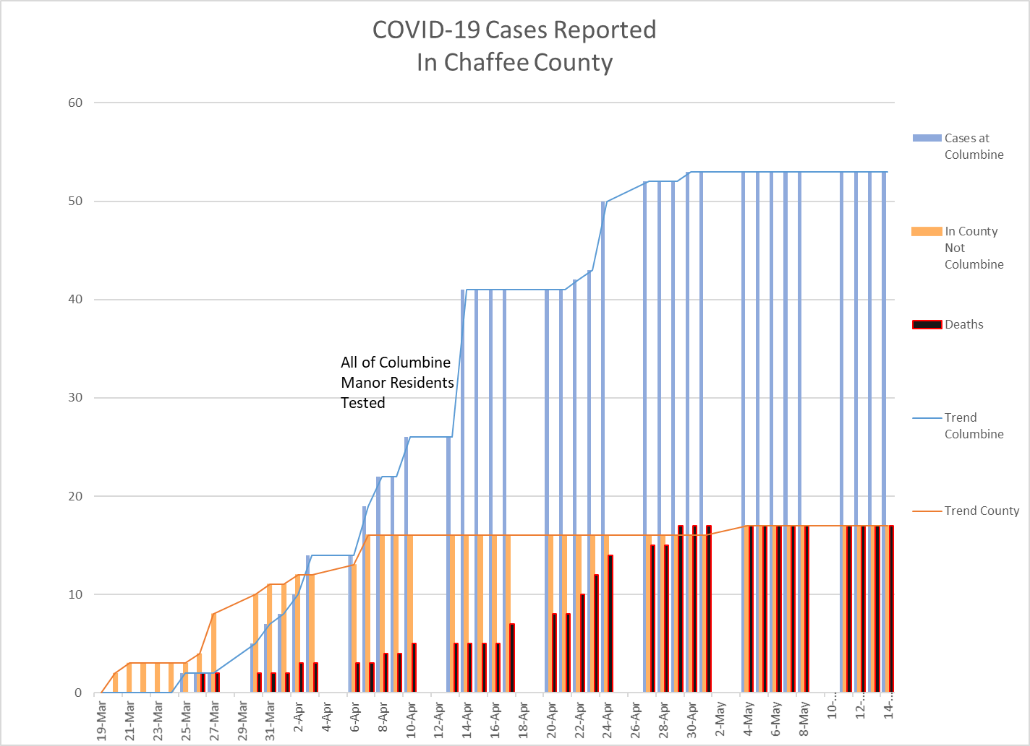

On Friday, April 24th the County working cooperatively with the municipalities, school districts, Chaffee County Economic Development Corporation and others released a plan.

# Sources and Charts

## Chart 1 – COVID-19 Rates by Nation[1]

The rate of deaths in the US has been increasing faster than any other country.

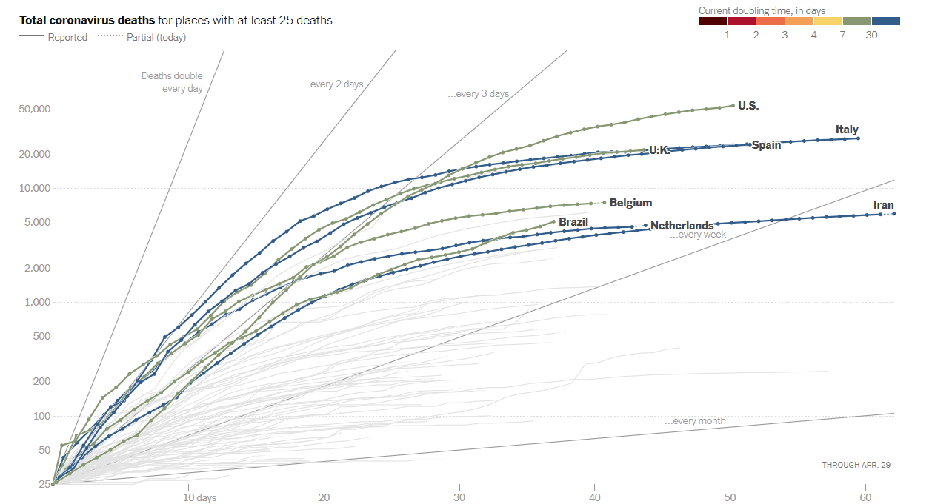

## Chart 2 – COVID-19 Rates by State

The State of Colorado has done better than many states in flattening the curve, but the state is still in the top 20 or so states.

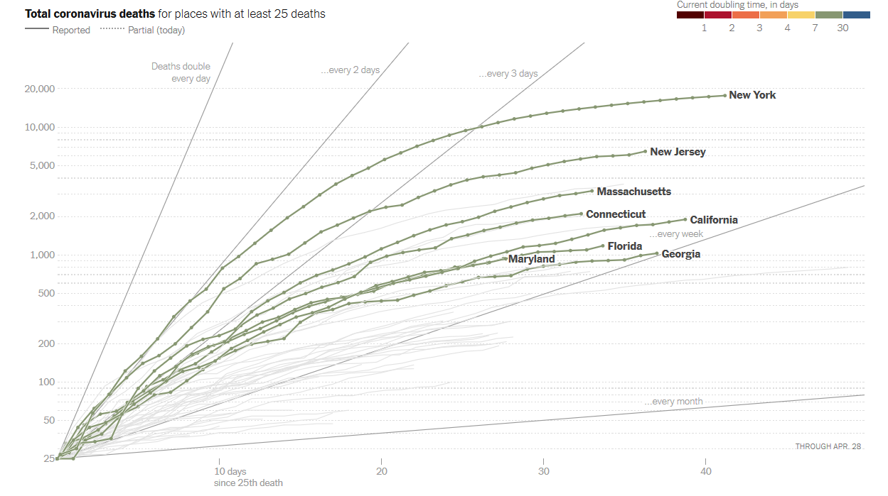

Colorado

Comparing Colorado to other states based on deaths as a share of the population, Colorado did significantly better than large, populous states, but not as well as other western states[2].



Other Colorado Trends that seem to be heading in the right direction

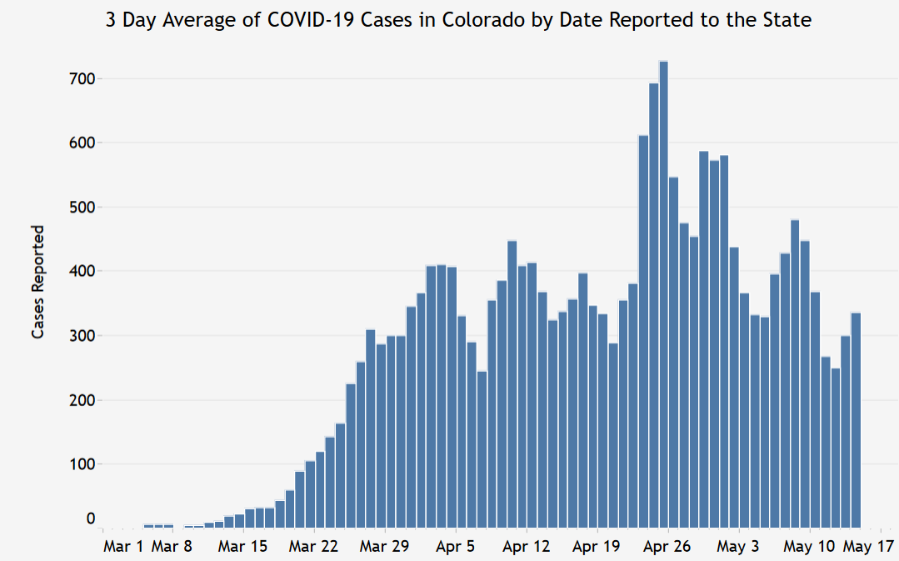

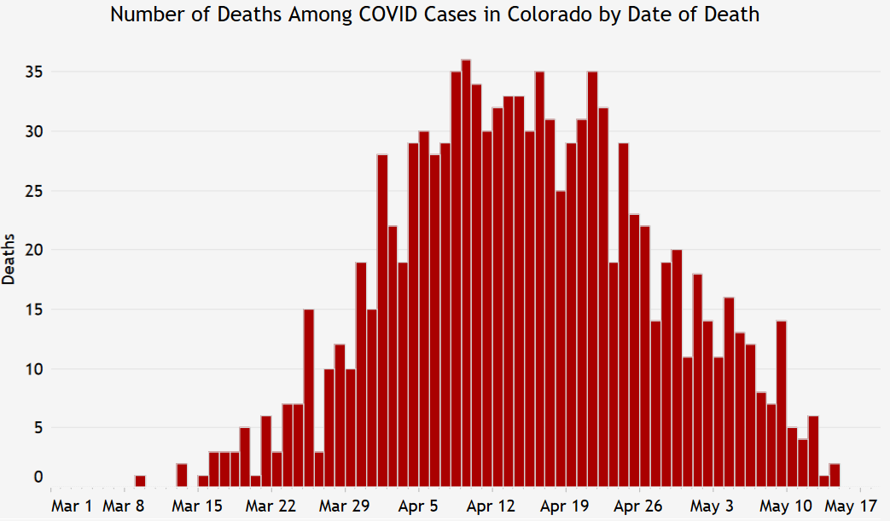

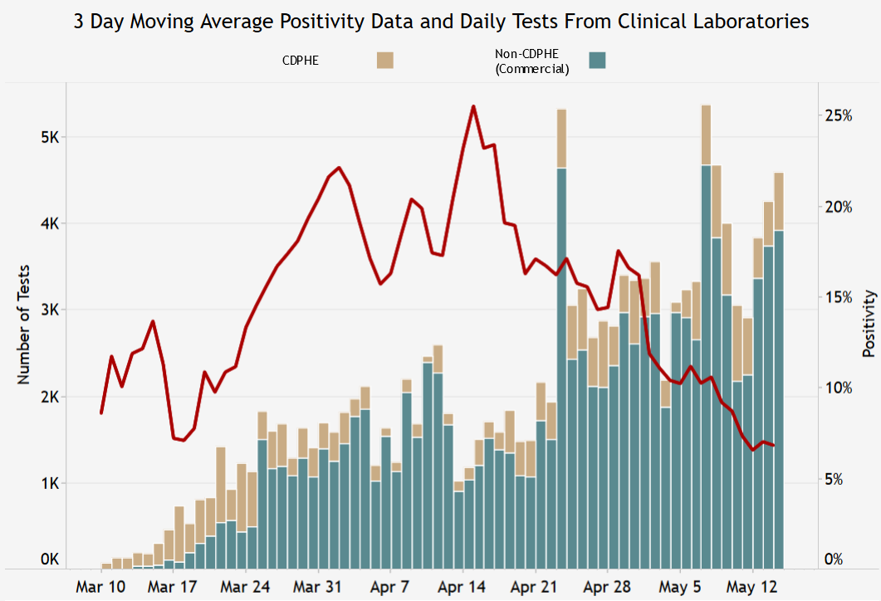

The three charts above are from CDPHE data site as of 5-15-2020. https://covid19.colorado.gov/data/case-data

1. The New York Times has been providing statistics on the number of reported cases and deaths on the following website: https://www.nytimes.com/interactive/2020/03/21/upshot/coronavirus-deaths-by-country.html?campaign_id=9&emc=edit_NN_p_20200325&instance_id=17048&nl=morning-briefing&regi_id=95367120&section=topNews&segment_id=22795&te=1&user_id=d77adeb6c0ea0e0a703f2310fdb9952e
2. Source: New York Times database of reports from state and local health agencies and hospitals as of 5-15-2020