Chaffee County Community Foundation

Board Meeting
Mar. 25, 2019 ♦ 3:00 pm

Participating Board Members:
Merrell Bergin | Rick Hum
Ed Cooper | Gordon Schieman
Wendy Hall

Regarding Board terms: Gordon said he is happy to finish his term this year or continue through 2020. Cindy told Ed that she feels she has to resign from this Board; just no availability to participate.

Minutes from the February meeting were approved.

I. Chair’s Report
- Ed met with Art Hutchinson; Art is “considering” it. Gordon will see Art on Wed. and will discuss CCCF with him further. Also met with Matt Burkley, who is also considering it; Matt is worried out having the time available.
- The search committee has had phone interviews with three viable candidates for Executive Director. Two have grant writing experience; Merrell agreed the candidates are promising. Ed said the Search Committee will interview these candidates, then make a recommendation to the Board, and the Board will then meet the recommended candidate(s). Everyone wants this to continue moving forward to a good resolution quickly.
- Update on D&O Insurance – The cost came in higher than the Board had approved because The Hub only bundles D&O with add’l insurance. Merrell is checking with the company that offers D&O insurance for his HOA.
II. Community Checkup Survey: Rick said they want to wrap up this up soon. Kim Marquez submitted comments to Rick and Irv. Curtis Jones is a statistician who has offered his expertise to help with the data. Rick said this report/data is now the baseline so CCCF can do the next checkup in two years. Rick noted that ratings and comments show that people feel pretty good about Chaffee lifestyle/conditions right now, but are less favorable about the future. He said they are guarded rather than optimistic.

The report needs to be posted, with links to the results advertised. People who responded and wanted to see the final report will be notified it is ready. Rick’s question is where should the repository for it be? The CCCF website is in transition. Envision will post it and that link can be sent out. Notice that the report is posted can also be put on the CCCF Facebook page. Once the CCCF website is in a more final state, the Community Checkup can reside with CCCF.

III. Old Business
1. The Foundant MOU with the County is with Jenny Davis to put together the legal format required. Jenny is not the decisionmaker; that is Bob Christianson and/or Dan Short, who will make the recommendations to the Commissioners about how this should be handled.

Rick said the Administrator for METAB will most likely be the Admin for Common Ground also. Rick suggests that Michael meet with Dan Short and Bob Christianson to get this accomplished.

2. Rachel Walke confirmed she will assist with the 990. Merrell asked if an Engagement Letter is required if services are done pro bono.

IV. Nominating Committee – need new suggestions to expand the Board. Suggestions were:

Chuck Rose – prior mayor; Gordon suggested, Merrell knows him. Chuck works at Absolute Bikes.
Danielle Forrest (Frost?) - a manager at Soulcraft; Rick suggested she might be good.
Andrew from 7’000-Ft Running Club was previously mentioned. Ed said Andrew is now in the process of an acquisition, so timing isn’t good.
Gregg Wilkins – Ed spoke with Gregg briefly at the 1A Commissioner Hearing. Wendy will try to contact him and set a meeting with Gregg and Rick to hook up.
Cheryl Brown-Kovacic is coming off of Salida City Council. However, decision that it is best for any elected/ political person have a “pause” before being considered as a member of CCCF.
Julie Klein – Wendy asked if Julie is still under consideration. There are significant pros and cons to having a non-Coloradan, but prestigious individual attached to the organization. Tabled for later discussion.

IV. Advisory Teams – more discussion on this when Lisa is here, but Board needs to be certain of the most critical core initiatives.
The next meeting is April 22nd; location to be determined.
Scheduling forward: the 4th Monday in May is Memorial Day; need to determine a different day to meet.
Action Items
1) Succession plan / Board training to be developed
2) Directors & Officers insurance – Michael?
2) Discussion re: Julie Klein – Ed
3) Search Committee – need to create for E.D. search – ED
3) HR manual – Syd /Merrell to start
4) Position description for Board officers – Current Officers to draft
5) CCCF needs Grants Committee; needs AdvTeam members selected for this
6) Agreement to be signed by Advisory members for term through 2019
7) Proposals written for Chaffee County, BV, Salida and Poncha (Michael / Ed ????)
8) Determine the specific initiatives CCCF wants to support in the short- and long-term
9) Method for recording In-Kind donations, like if printing is donated. - Michael
10) Roundtable discussion with 10-15 top stakeholders/leaders/nonprofits about their needs and concerns - (?? and when?)
11) Discuss proprietary website platform with Michael DiLillo – (down the road)
12) Identify non-supporters and determine what their concerns are via sit-down conversations with them.
13) Cindy to provide Syd list of everyone Envision is contacting for funding. (Cindy – done?)
13) Purchase and implementation of Foundant software – in process (Michael)
Submitted by Wendy Hall 3/6/2019.
= = = = = = = = = = = = = = = = = = = = = = = = = = = = = = = = = = = = = = = = = = = = = = = = = = = =

[agenda next page]

Chaffee County Community Foundation

Board Meeting Agenda

March 25, 2019 ▪ 3 PM

[At the Cooper’s]
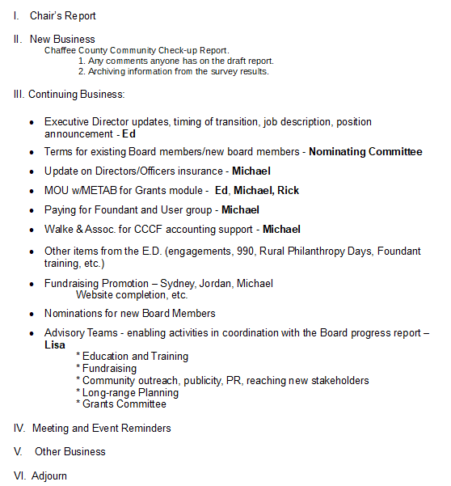

++ Next meeting April 22, 2019 @ 3 PM ++ Determine location.

