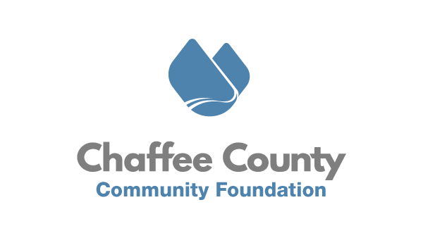
October 22, 2020
FOR IMMEDIATE RELEASE
New Coronavirus Relief Fund Program Expands to Include Chaffee Small Businesses

Chaffee County, CO – The Chaffee County Community Foundation (CCCF) is pleased to announce that its Coronavirus Relief Fund (CRF) program has been expanded to serve Chaffee small businesses. On Thursday, October 22nd, the Chaffee County Board of County Commissioners approved $150,000 on for small business relief to join with the already allocated nonprofit relief dollars administered by CCCF. These funds are open to, and meant to serve, any Chaffee small business who has faced a loss or expense related to COVID-19. Funds will prioritize businesses who have a brick and mortar location subject to a 50% occupancy restriction from public health, however all small businesses operating in compliance with public health guidelines are encouraged to apply.

Applications will be accepted beginning Wednesday, October 28th, 2020, and will be considered on a first come, first serve basis through November 30th, or whenever funds run out, whichever comes sooner. Details on this program and the link to access the application can be found at www.chaffeecommunity.org/crf.

This application and opportunity have been created collaboratively with expert input from the Chaffee Small Business Coalition and the office of the County Commissioners. Small businesses with detailed questions about eligibility or how to complete the application can reach out to any Small Business Coalition member organization as well as to grants@chaffeecommunity.org.

CCCF Executive Director Joseph Teipel says, “Working with our small business partner organizations to ensure this opportunity meets the actual needs of small businesses in our community has been a great honor. While CCCF has been focused on assisting nonprofits and individuals, we recognize the crucial role businesses play in making this an incredible place to live and we are excited to be able to offer our help to them as well.”

Chaffee County Public Health Director Andrea Carlstrom says, “We already have businesses that have had to temporarily close their doors due to positive cases, and this gives me tremendous relief to know that there are resources and supports for them, especially as we move into these cooler and unpredictable months.”
This grant opportunity is only one small part of a larger suite of services and supports the Chaffee Small Business Coalition is providing to businesses impacted by COVID-19. Coalition member organizations have put together menus of approved heating and ventilation equipment, are standing ready to assist small business owners in completing this CCCF grant application, and can provide more in-depth counseling and business planning services. Interested business owners should contact the Central Mountain Small Business Development Center, the Salida Business Alliance, the Buena Vista Chamber of Commerce, or the Salida Chamber of Commerce. More resources can be found here: https://centralsbdc.org/.

###
About Chaffee County Community Foundation (CCCF)
CCCF envisions a resilient Chaffee County where residents, nonprofits, businesses, and governments are thriving, interconnected, and well resourced. CCCF’s mission is to act as a catalyst to inspire positive change through the power of philanthropy to enrich the lives of all people in Chaffee County. To do this, CCCF is working with nonprofits, residents, businesses, and municipal governments to increase philanthropy, provide capacity building and technical support to nonprofits, and invest in catalytic projects in the areas of Community Vitality, Community Health, and Community Capacity. In addition, CCCF aims to act as a ‘center for the common good’ by holding space for community conversations
and dialogue on tough issues. Learn more at www.chaffeecommunity.org.

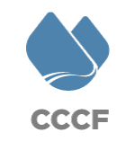

Joseph Teipel
Executive Director
(719) 204-5071
joseph@chaffeecommunity.org

