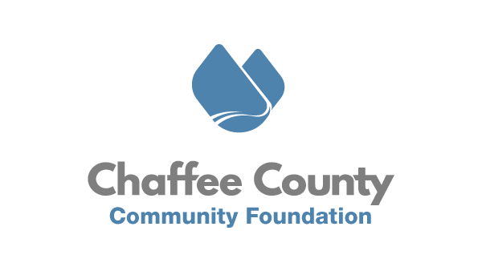
September 16th, 2020
FOR IMMEDIATE RELEASE
CCCF Announces New Coronavirus Relief Fund Program

Chaffee County, CO – The Chaffee County Community Foundation (CCCF), together with the City of Salida, Board of Chaffee County Commissioners, and the Town of Buena Vista, is announcing a new funding program for Chaffee nonprofits and community designed to provide financial relief to organizations and address youth programming needs as an uncertain school year lays out ahead. Using up to a combined total of $200,000 in allocations from their CARES Act Coronavirus Relief Fund dollars, each of the three local governments have engaged CCCF to design and administer a reimbursable grant program. Applications will go live on Thursday, September 24th at 6am and will utilize the online grants portal accessible from www.chaffeecommunity.org/grantmaking.

This partnership and resulting grant program will have two primary funding ‘buckets’. A general nonprofit relief fund of $140,000 will focus on helping Chaffee nonprofits recoup lost revenue or direct expenses related to COVID. Applications will ask organizations to provide clear and objective documentation which details their COVID-related revenue losses (i.e. from a cancelled event), or their COVID-related expenses (i.e. cleaning and sanitation supplies). Complete applications for this relief fund will be due by 5pm on Monday, October 12th. Approved grants will reimburse organizations up to $7,500 or 20% of their 2019 operating budget, whichever is less.

The second part of this program is a $52,500 fund designed to reimburse nonprofits, businesses, churches, and other entities for documented expenses related to providing youth care and programming for Chaffee youth who are either on COVID-related remote learning, or whose parents are essential workers. Applications will ask entities to provide receipts for costs incurred in providing this programming or care (i.e. safety training or background checks, facilities costs, staffing and supervision, food, health equipment, etc). Complete applications for this program will be due by 5pm on Sunday, October 18th.

“Once again our elected leaders of the county and municipalities are demonstrating their commitment to thinking creatively and intentionally about the needs facing our nonprofits and families. This program will unlock federal dollars to go to work for our community and CCCF is honored to be a part of it.” says CCCF Executive Director Joseph Teipel. Chaffee nonprofits and other entities are encouraged to prepare their documentation of COVID-related losses and expenses to participate in this program. Ensuring full utilization of these dollars will help CCCF and the local governments understand the ongoing needs in the community and evaluate whether additional allocations are warranted.

Follow CCCF on Facebook and Instagram, or sign up for their newsletter at www.chaffeecommunity.org to get notifications and updates.
Simple idea. Lasting impact.

###
About Chaffee County Community Foundation (CCCF)
CCCF envisions a resilient Chaffee County where residents, nonprofits, businesses, and governments are thriving, interconnected, and well resourced. CCCF’s mission is to act as a catalyst to inspire positive change through the power of philanthropy to enrich the lives of all people in Chaffee County. To do this, CCCF is working with nonprofits, residents, businesses, and municipal governments to increase philanthropy, provide capacity building and technical support to nonprofits, and invest in catalytic projects in the areas of Community Vitality, Community Health, and Community Capacity. In addition, CCCF aims to act as a ‘center for the common good’ by holding space for community conversations
and dialogue on tough issues. Learn more at www.chaffeecommunity.org.

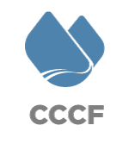

Joseph Teipel
Executive Director
(719) 204-5071
joseph@chaffeecommunity.org

